1
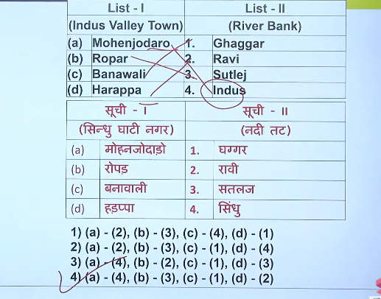
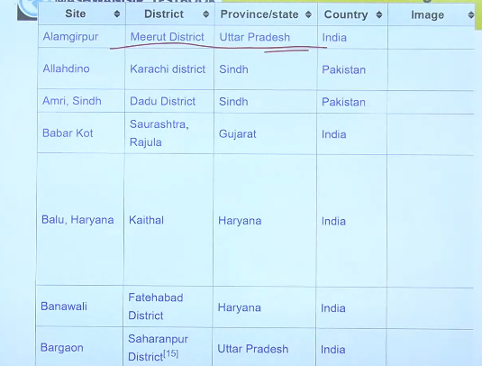
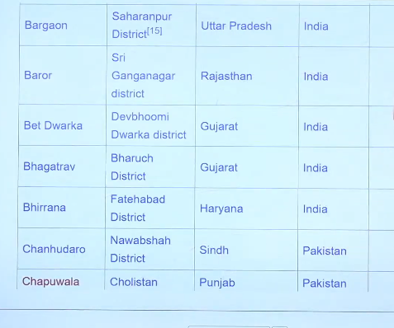
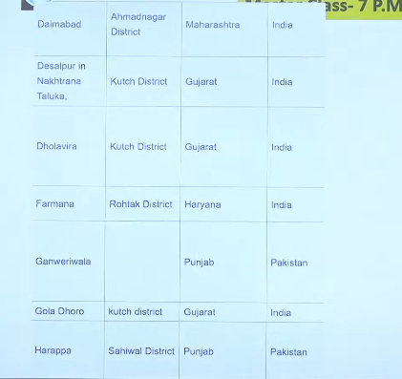

2
Mandal -9 Ans:3
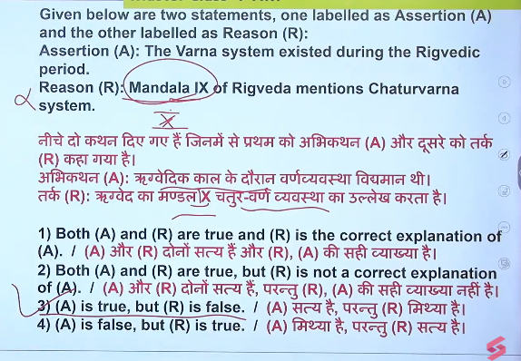

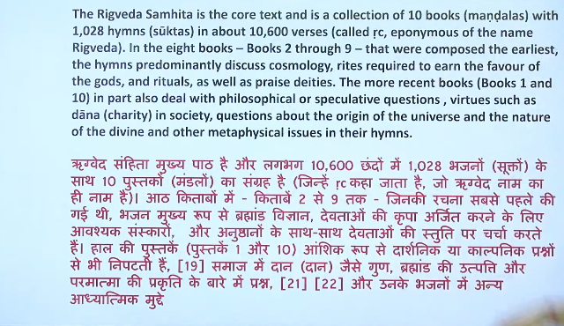

The Varna system was introduced during the Early Vedic Period (around 1500–1000 BCE), with its earliest mention appearing in the Purusha Sukta hymn of the Rigveda. Initially, it was a flexible social classification based on occupation and merit, which later became hereditary and rigid during the Later Vedic Period (1000–600 BCE).
Vajiram & Ravi +4
Key Details of the Varna System's Origin:
- Initial Purpose: The system was meant to organize society into four distinct roles—Brahmins (priests), Kshatriyas (warriors), Vaishyas (merchants), and Shudras (laborers).
- Initial Flexibility:
In the early stages, an individual's varna was based on their profession and could be changed, rather than being determined by birth.
- The Purusha Sukta: The 10th Mandala of the Rigveda provides the first theological description of these four classes originating from different parts of a cosmic being (Purusha).
- Evolution: It evolved into a rigid caste system based on birth over the following centuries, as discussed in literature like the Wikipedia and Britannica.
Contextual Factors:
- Transition: It shifted from a relatively open structure to a closed caste structure during the Later Vedic period (1000–600 BCE).
- Social Function: The system was used to create a hierarchical social order and maintain the division of labor Prepp.

3
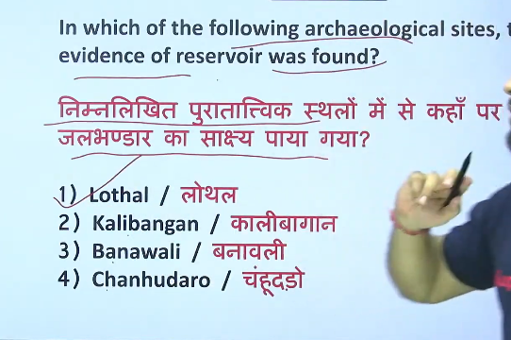
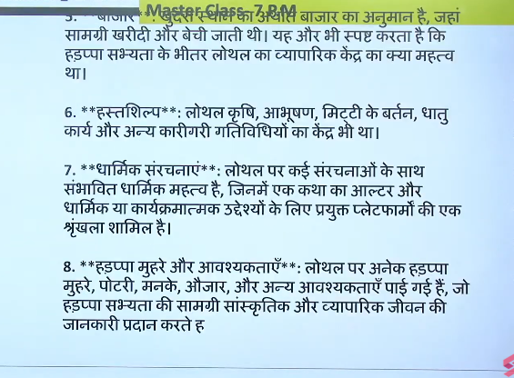
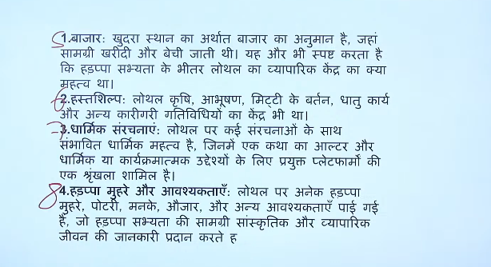




Dholavira in Gujarat is the premier Harappan site renowned for its sophisticated water management system, featuring massive stone-cut reservoirs. It boasts huge water reservoirs on the north, south, and east, along with check dams used for storing rainwater. Another significant reservoir was identified at Rakhigarhi, Haryana.
Testbook +3
Key Water Reservoir Sites & Features:
- Dholavira (Gujarat): This site represents the most sophisticated water storage, using reservoirs, dams, and interconnected drains. The reservoirs are carved from rock and were used to secure water in the arid region.
- Lothal (Gujarat): Known for a massive, sophisticated dockyard or basin associated with tidal water management.
- Rakhigarhi (Haryana): A massive reservoir has been identified, highlighting the advanced water storage capabilities of the largest Harappan city.
- Surkotada (Gujarat): Similar to Dholavira, this site shows evidence of water conservation in the Kutch region.
Evoke Dholavira +4
These sites show that Harappans had exceptional knowledge of hydraulic engineering and water harvesting.
Dholavira in Gujarat is the most significant Indus Valley Civilization site for water reservoirs, featuring an advanced, ancient water management system with multiple, large, stone-cut reservoirs designed for rainwater harvesting. Other major sites with water management infrastructure include Lothal, with its large dockyard, and Rakhigarhi.
www.harappa.com +3
- Dholavira (Gujarat, India): This site, located in the Kutch region, is known for its sophisticated network of at least 16 reservoirs and rock-cut cisterns around the city, designed for storing rainwater. The largest ones are built on the northern perimeter and are linked by a complex drainage system.
- Lothal (Gujarat, India): Known as the industrial dockyard of the civilization, it features a massive artificial dock. It also has a unique inlet channel to control water levels and prevent siltation.
- Rakhigarhi (Haryana, India): A massive reservoir was discovered here, considered second only to Dholavira's, indicating advanced engineering to store water from the surrounding seasonal river (Drishadvati) around 3,000 BCE.
- Mohenjo-Daro (Sindh, Pakistan): Famously features the "Great Bath," a large public water tank built for bathing or communal purposes, alongside a sophisticated, well-maintained drainage system.
Wikipedia +5
These water management sites are crucial because they demonstrate the Harappans' ability to engineer water solutions in dry environment

4
Ans: 4
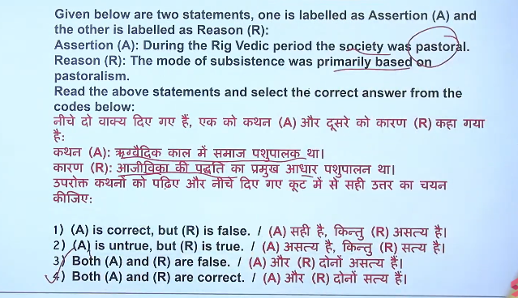
5
The Panchajana (or Panchakrishtya / Panchanaram) in the Rig Veda refers to five prominent Aryan tribes. These tribes, which constituted the main Vedic Aryan society, are identified as the Puru, Anu, Druhyu, Yadu, and Turvasha. They were a cultural and linguistic group distinct from the non-Aryan Dasyus or Dasas.

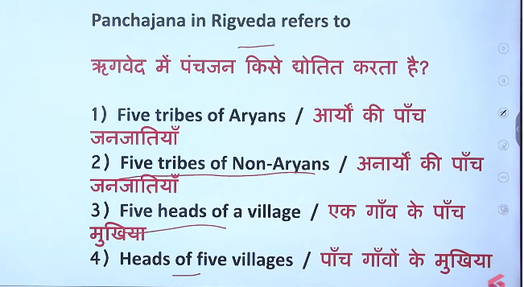
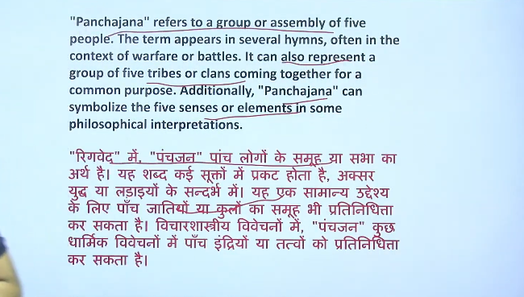

Panchajan (meaning "five people" or "five tribes") refers to five major Aryan tribes/clans mentioned together in the Rig Veda (I.108.8).
Indiafacts
Key details about the Panchajana:
- The Five Tribes: They are specifically identified as the Yadu, Turvasha, Puru, Anu, and Druhyu.
- Identity: They are considered the most ancient Vedic Kshatriya clans, closely associated with Indo-Aryan culture.
- Context: The Rig Veda often describes these tribes fighting among themselves or against others, including non-Aryan tribes, but they themselves are core Aryan people.
- Battle of Ten Kings: In the Battle of Ten Kings (Dasarajna), five of the tribes opposing the Bharata king Sudas were Aryan (belonging to this Panchajan group), and five were non-Aryan (Dasas/Dasyus), showing a mix of conflicts, not that the Panchajan were entirely non-Aryan.
Wikipedia +2
Non-Aryan Tribes: In contrast, the Rig Veda refers to indigenous groups or opposing non-Aryan tribes as Dasas or Dasyus

6

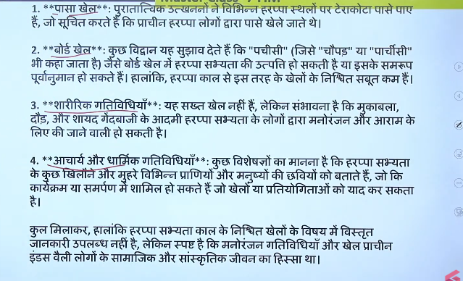
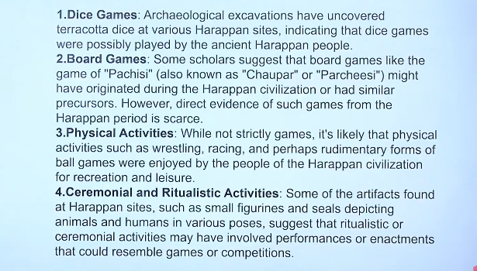

7
Ans: 2 is correct answer
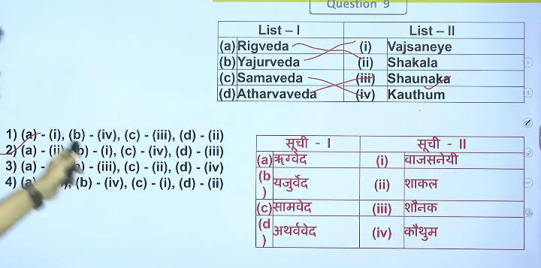

8
Ans:a

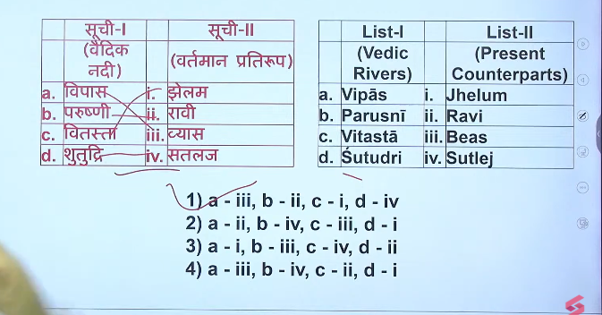

9
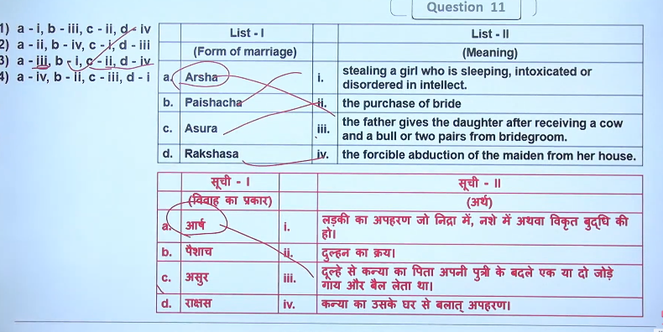
Ans: C

10

Ans: 4

11
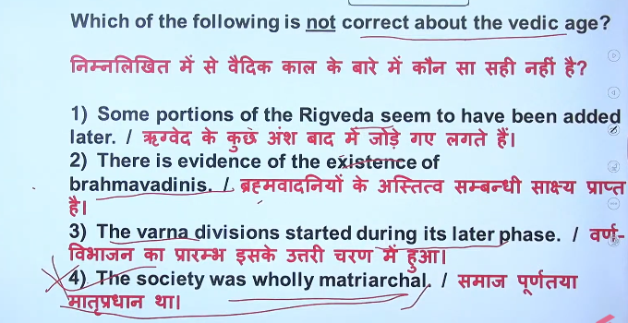
Ans: 4

12
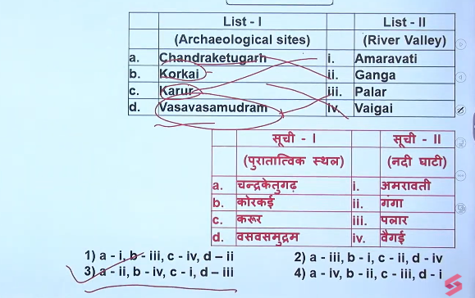
Ans: 3
13

Ans: 2

14
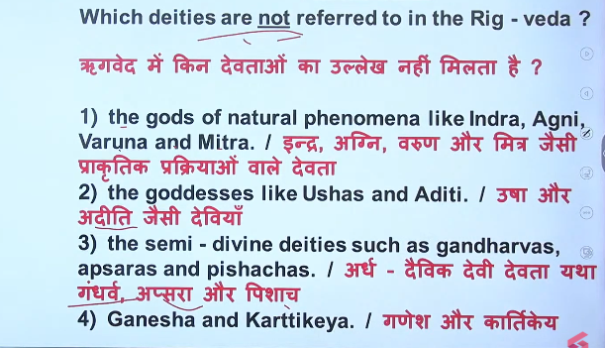
Ans: 4
These show in late vedic period
15

Ans:2
16
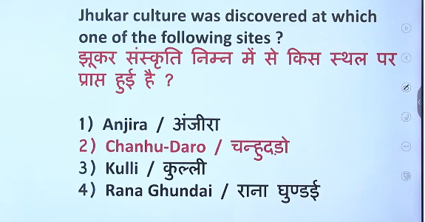
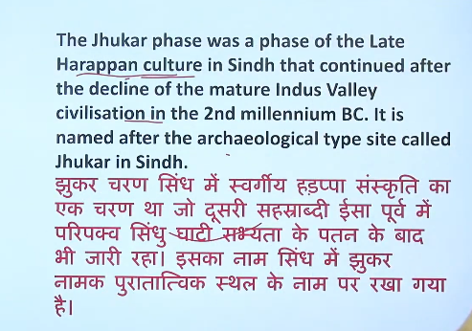
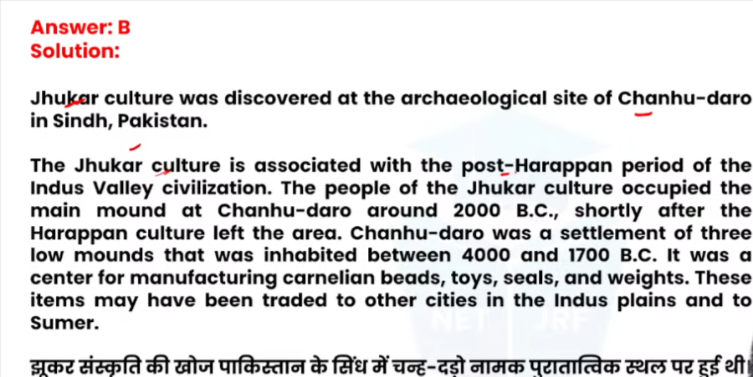

17
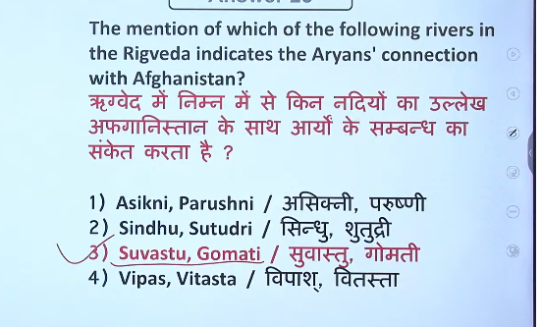
Ans: 3

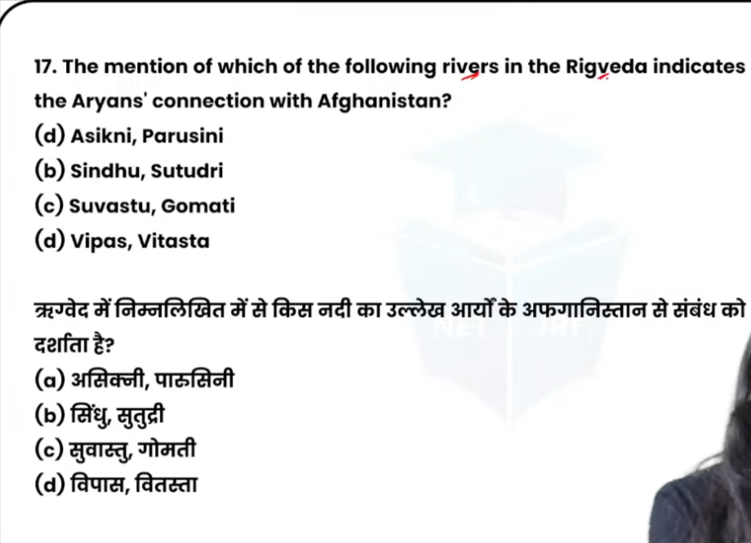
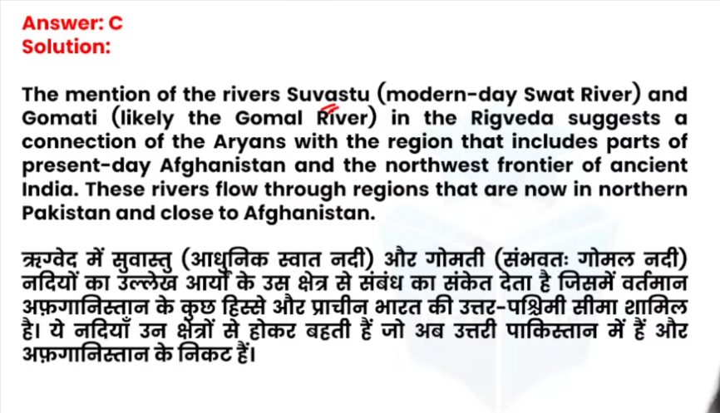
18

Ans:3


19
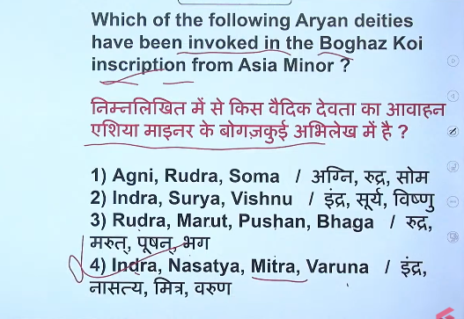
Ans: 4
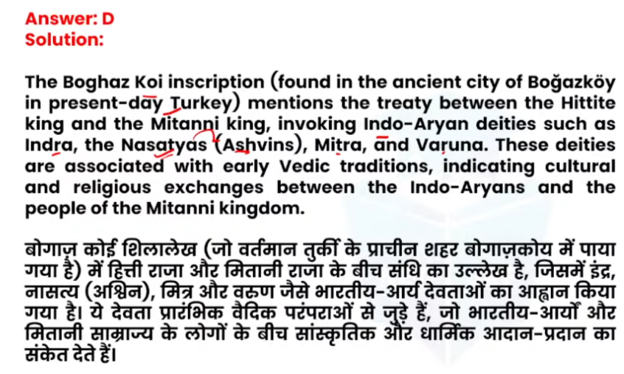

20
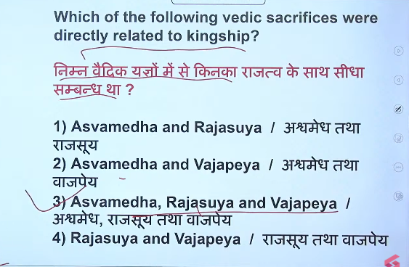
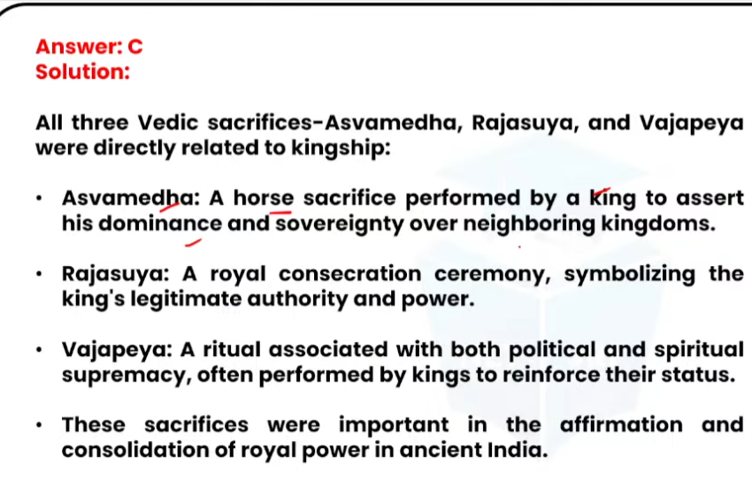


21


22
